
Microsoft Lync 2010 for Android
Microsoft® Lync™ 2010 for Android brings presence, instant messaging (IM), and the voice capabilities of Lync to your mobile device. With Lync for Android, you can choose from multiple ways to communicate with others, including IM, or calling using either your work or mobile number.
Lync for Android provides access to your Contacts list when you are away from the office, so that you can check your co-workers’ presence status and availability before contacting them. You also have access to the company directory, so that you can look up contact information, including additional phone numbers, schedules, and personal notes.
Use this guide to learn how to do the following tasks in Lync for Android:
Installation Prerequisites
Install Lync
Sign into Lync
Use Lync for the first time
Your Lync conference dialing number
View and search for contacts
Search for a contact
View a contact card
Call or send an instant message (IM)
Send an email from a conversation in your Chats list
Set your status
Type your note
Set your Options
Forward calls to voice mail or another number
Simultaneously Ring another number
Turn photos on or off
Join a Meeting

Installation Prerequisites
To run Microsoft Lync 2010 for Android, the phone must be running Android 2.3 or a later phone-oriented operating system.
Installing the Microsoft Lync 2010 application on your mobile phone is as easy as installing any other application on your phone.
Install Lync
Installing the Microsoft Lync 2010 application on your mobile phone is as easy as installing any other application on your phone.
- From your phone, go to the Android Market, and search for Microsoft Lync 2010.
- Tap the Install button. As soon as the app is installed, it appears on your phone.
Sign into Lync
If you have a data plan, or your phone is connected to a Wi-Fi network, signing in is as easy as launching an application.
- On the home screen, tap the Lync 2010 icon.
- On the sign-in screen, enter your credentials, and then tap Sign In.
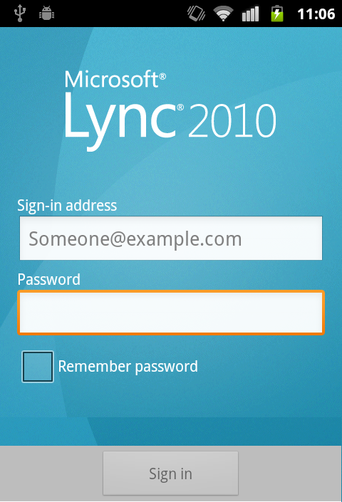

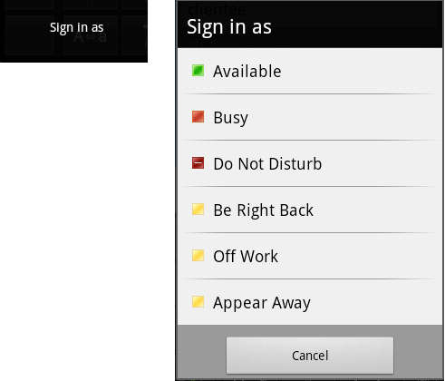
Note
If you want to specify a status upon sign-in, tap the Menu icon, tap Sign in as, and then tap a status in the list.
Use Lync for the first time
The first time you sign into Lync on your mobile device, the Terms of Use appear. You are also guided through adding your mobile phone number. By adding your mobile phone number, you can use your mobile phone to join Lync conferences.
- On the welcome screen, type in your mobile phone number.
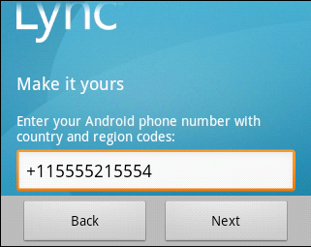
- Tap Next.
Your Lync conference dialing number
Lync automatically sets up your mobile phone number as your Lync conference dialing number so that you can quickly join the audio portion of Lync meetings. When you click the Join online meeting link in a meeting invitation, Lync calls you at your mobile phone number and joins you to the conference. If you want to verify your conference dialing number, use the following steps.
- Tap My info, and then tap Options.
- Under Meeting access, verify that your mobile phone number is correct.
Note: To use a different number, tap Meeting access, tap New number, and then type a new number.
View and search for contacts
When you sign in to Lync, you can see your Contacts list. Your Contacts list is a list of co-workers, family, and friends with whom you communicate most often. The Lync Contacts list on your mobile device, are the same contacts in your Microsoft Lync 2010 Contacts list on your computer.
Search for a contact
- Tap Contacts.
- Tap the menu icon, and then tap Search.

- In the search box, start typing a person’s name. The results appear below the box.
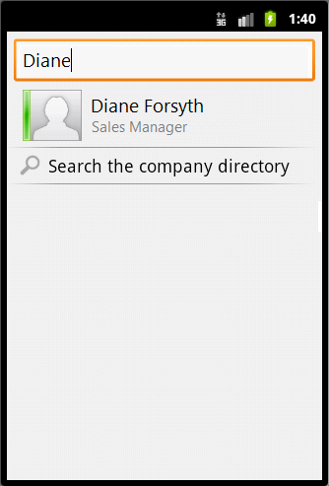

View a contact card
When you find the person you’re looking for, tap the person’s name to view his or her contact card.
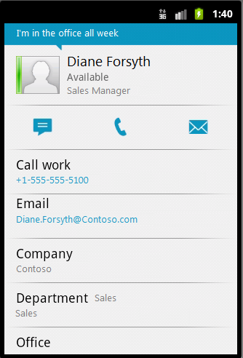
Call or send an instant message (IM)
To call or send an instant message to one of your contacts:
- Tap Contacts.
- Tap the person’s name, and then tap the IM icon.
To call or send an instant message to someone who is not in your Contacts list:
- Tap Contacts.
- Tap the menu icon, and then tap Search.
- In the search box, start typing a person’s name. In the search results list, tap the person’s name.
- Either tap the number you want to call, or tap the IM icon.
Send an email from a conversation in your Chats list
You can use your Chats list to send an email to someone with whom you’ve had an IM conversation. The email contains the content of that IM conversation.
To send an email from one of the conversations in your Chats list:
- Tap Chats.
- Find the conversation with the person to whom you want to send an email. Tap and hold the conversation until a menu appears.
- In the menu, tap Send as email. The email will open in your email client.
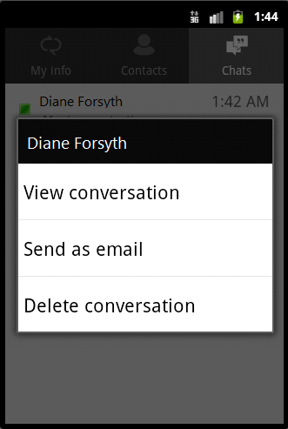

Set your status
If you do not want to be disturbed or you plan to be away from your mobile device, you can manually change your presence status from Available to Busy, Do Not Disturb, Be Right Back, or Appear Away.
To change your status:
- Tap My info.
- On the My info screen, tap the arrow next to your current status.
- Under Set my status , select a status.
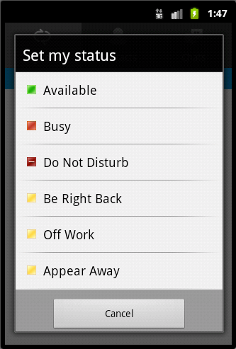

Type your note
Your note appears on your My info screen and in your contact card. You can update the note with any text you want. For example, you can change your note to reflect where you are currently or how you prefer to be contacted at any given time.
To change your note:
- Tap My info.
- Tap the What’s happening today? text balloon and type a note.
- Tap OK.
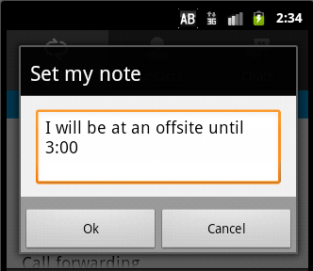
Set your Options
Forward calls to voice mail or another number
The Call Forwarding option is typically used to forward calls directly to your voice mail or to a number other than your mobile number.
- Tap My info, and then tap Call Forwarding.
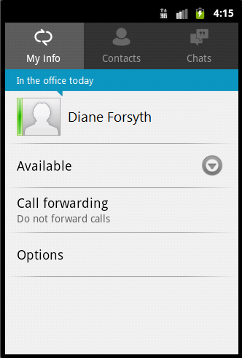
- On the Call forwarding settings screen, tap Forward calls.
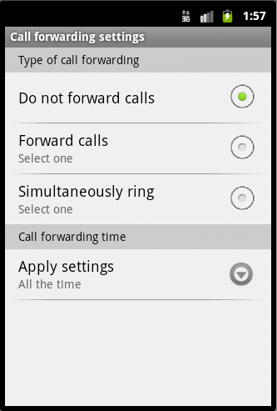
- On the Forward calls to screen, do one of the following:
- Tap one of the phone numbers you had entered previously.
- Tap Voice Mail to forward calls directly to your voice mail.
- Tap My Delegates to forward calls to people you have already set up as your delegates.
- Tap New Number, and then in the New number screen, type a phone number.
- Tap Select Contact. On the Select contact screen, tap one of your contacts. Or, in the Search box, type someone’s name, and then tap his or her name in the results list.
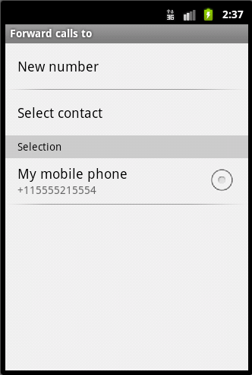
Simultaneously Ring another number
Lync automatically sets up your mobile phone number to ring simultaneously when you receive a work call. If you have already set up delegates or a team-call group in Lync on your desktop, you can choose to simultaneously ring them instead of your mobile phone. Or you can enter another number.
- Tap My info, and then tap Call Forwarding.
- On the Call forwarding settings screen, tap Simultaneously Ring.
- On the Simultaneously ring screen, tap one of the options.
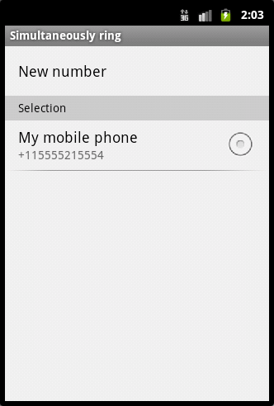
Turn photos on or off
You can turn the photo feature on or off. This setting determines whether photos display in your mobile device only.
- Tap My info, and then tap Options.
- On the Options screen, tap Show photos to turn photos on or off.
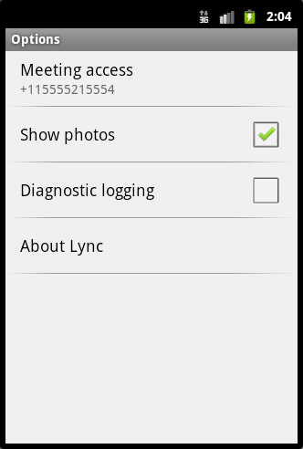
Join a Meeting
You can join an online meeting by clicking the link in the meeting invitation. The Lync meeting will call you back at your mobile phone number so that you can join meeting audio.
- In your calendar, open the meeting invitation.
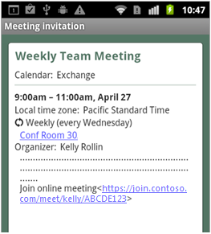
- Tap the Join online meeting link.
- When the Lync meeting calls you back, answer the call to connect to the meeting audio.
© 2011 Microsoft. All Rights Reserved.

