
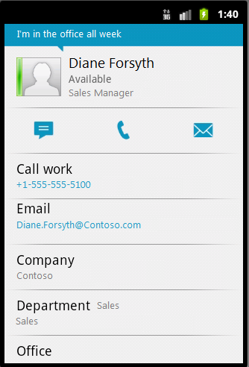
Make a Call
Calls made using Lync are not Voice over Internet Protocol (VoIP). When you make or receive a Lync call, your carrier’s minutes are being used.
- To call someone in your Contacts list, find the contact, tap the contact’s name, and then tap the number you want to call.

Join a meeting
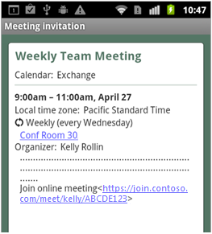
You can join the audio portion of a Lync 2010 meeting from your mobile phone.
- From your phone calendar, open the Online Meeting item for the meeting that you want to join.
- Tap the Join online meeting link. Lync calls you on your mobile phone.
- Accept the Lync call to join the meeting.

Quick Reference for Lync 2010 for Android
Sign in and get started
If you have a data plan, or your phone is connected to a Wi-Fi network, signing in is as easy as starting an application. For a list of supported features, see the Mobile Client Comparison Tables at http://go.microsoft.com/fwlink/?LinkId=234777.
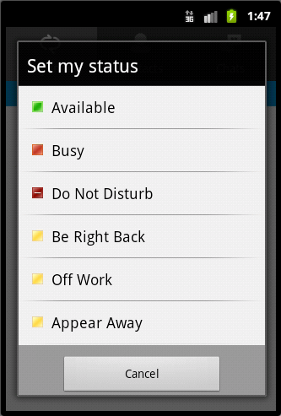
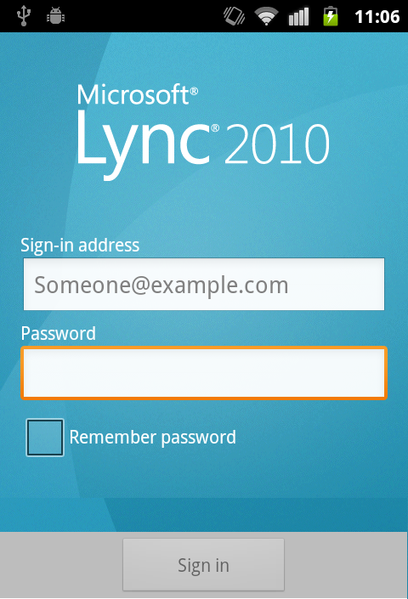
- On the mobile phone Applications screen, tap the Lync 2010 icon.
- On the sign-in screen, enter your credentials, and then tap Sign In.

Set your status
- On the My info screen, tap the arrow next to your current status.
- Under Set my status, tap a status in the list.

PRINT SETTINGS For best results, set printer options to: Paper Size: Letter (8.5x11”); Orientation: Landscape; 2-sided printing options: Two-sided, flip on short side.

© 2011 Microsoft. All Rights Reserved. This document is provided “as-is”. Information and views expressed in this document, including URL and other Internet Web site references, may change without notice. You bear the risk of using it. Some examples are for illustration only and are fictitious. No real association is intended or inferred.

Find the right person
You can find someone in your contact list by searching for them by name or phone number. If you want to find someone in your organization who is not in already in your contact list, you can search the company directory.
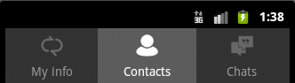
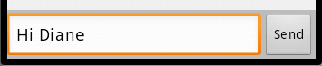
- From the Contacts screen, press the Menu button, and then tap Search.
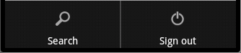
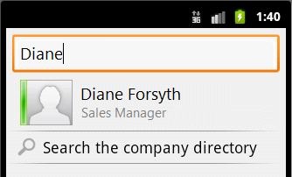
- Start typing a person’s name or phone number in the search box. If the person is already in your Contacts list, the results appear below the box.
- If the person is not already in your Contacts list, tap Search the company directory to search the entire organization.

Send an instant message
- When you find the person you’re looking for, tap the person’s name, and then on the contact card screen, tap the IM icon.

- Type a message, and then tap Send.
Receive an instant message
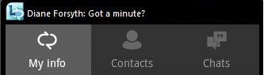
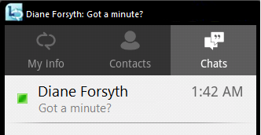
When someone sends you an instant message, an instant message alert appears at the top of the screen. The IM alert appears only for a few seconds, but you can tap the Chats icon to view any missed instant messages.
To accept an IM invitation, do one of the following:
- Tap the IM alert, or
- Tap Chats, and then tap the conversation.

Invite others to an existing IM
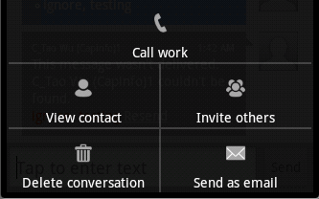
During an IM conversation, invite someone new by doing the following:
- From the IM conversation screen, press the Menu button, and then tap Invite others.
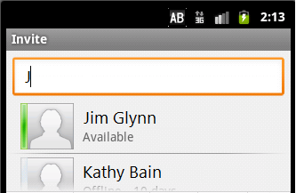
- Tap the contact, or search for the contact you would like to invite to the conversation.

