Here are the instructions to reset your phone. The key to the reset is when you press and hold * and # and unplug the cable do not release * and # when plugging the cable back in. You can release those keys when you see the message on the screen that says do you want to erase all user data and continue. Then you can release 4 and 6 and continue with the on-screen prompts. If you have any problems in the reset process please let me know.

Thanks!

Here are steps to do a factory reset on a CX600, This will reset the phone and wipe all settings including the lock pin

**FACTORY RESET CX600**

REVERT FIRMWARE AND WIPE CONFIGURATION

The *FACTORY RESET* wipes the configuration data and resets user information. This process triggers the device’s built-in protection mechanism.

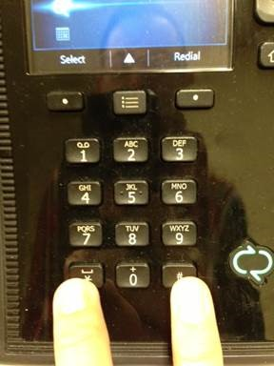

1.       Press and Hold the * and # key while the receiver is on the base and unplug the network cable.

2.       Still holding the * and # plug the network/LAN cable back in.

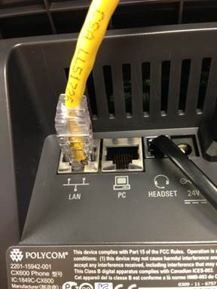

**LAN CABLE LOCATION**

Machine generated alternative text: The operation you have requested
will erase all user-created data.
Do you want to continue?

**Select Yes to continue**

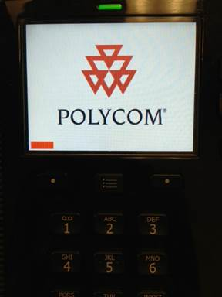

Machine generated alternative text: (flC2OlO
none Edition
licrosoft

Machine generated alternative text: Microsoft
C2010
dition

**Select Center button between up and down arrow to the right of the screen.**

Machine generated alternative text: Vælg dansk
Deutsch auswählen
Select English
Seleccionar Español
Valitse suomi
Sélectionner français
Seleziona italiano
ti ig1R

**Select Confirm on Language**

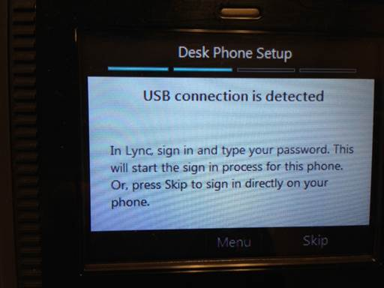

**At this step you need to sign into your Lync program on your computer (next picture) If you are not tethering your device the phone will ask for the extension and the pin (the pin will be the last 6 digits of the phone number.**

Machine generated alternative text: Logon information needed
nr*
A connection has been detected between your desk phone
and lync. To complete the connection, type your network
ogon password.
Account:
user name:
tristan.lowe@vanderbitt.edu
VANDERBILT\lowet
Password:
li
Nichols, Linda S - Available
Sianks, Tarnrny Catlin - A.i&lable
Wolff Taj S - •. aelable

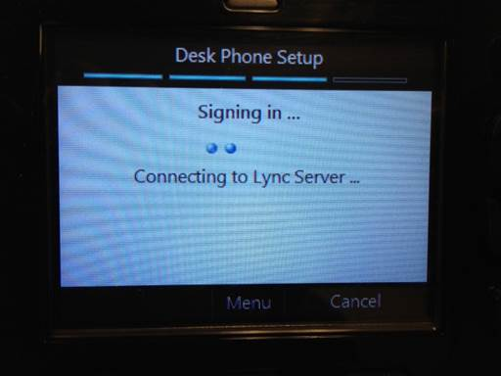

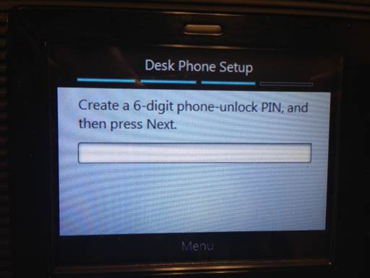

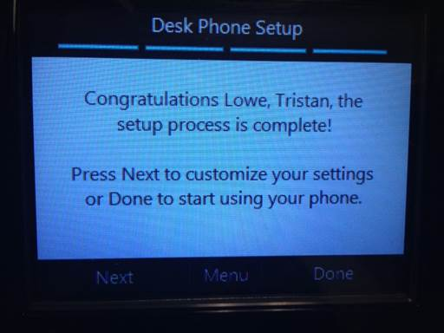

**Select Done**