GNAV Quick Start Guide

Logging in client:

User name and password are set up when initial configuration is done

Step 1 - Click the NEC GNAV Pro Client Icon

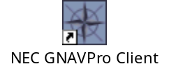
Step 2 - Enter user name and password
Step 3 - Server name is gnavpro.its.vanderbilt.edu
Step 4 - Click “OK”

The real-time screen will take 5-30 seconds to load. The GNAV client is finished loading and ready for use when steadily scrolls in the status box at the lower right corner of the screen.

Viewing the real-time screen:

The GNAV client will initially come up with a tree view frame on the left side of the screen. This frame can be toggled on and off with the first button on the toolbar. The button is labeled “tree view”.

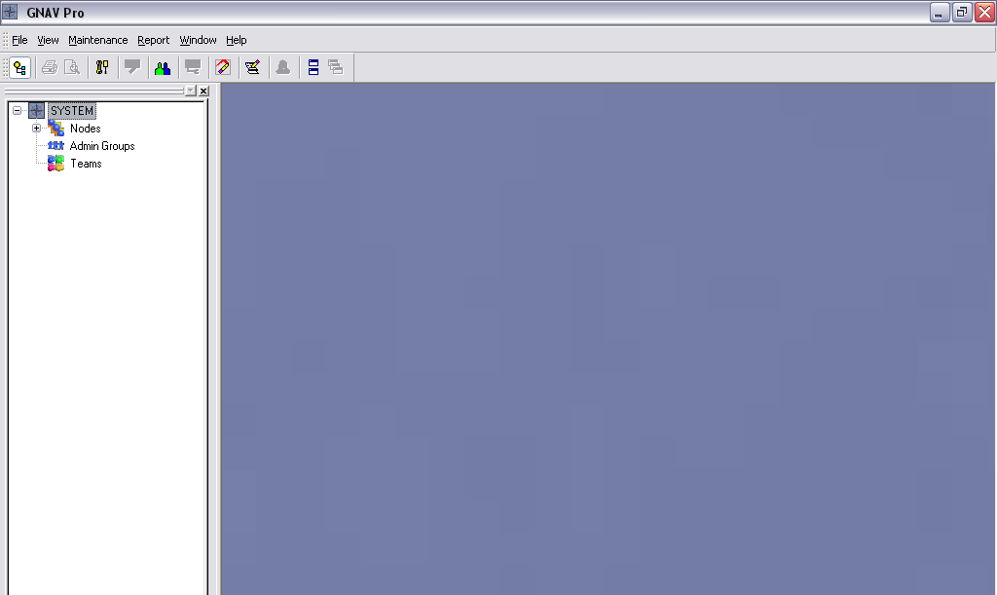

This tree will access the different window views available in GNAV:

Step 5 - At the bottom of the tree view window select the “Views” tab

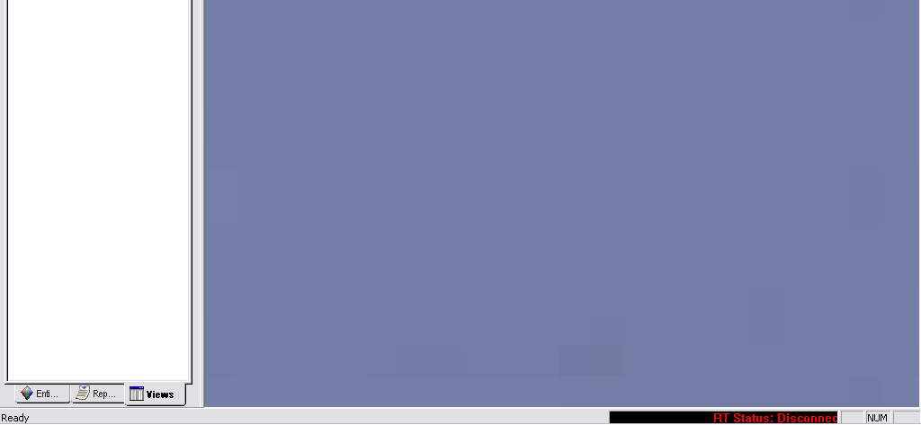

Step 6 - Click the plus signs ”+” for “REALTIME VIEWS” and “Default Views”
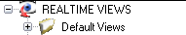

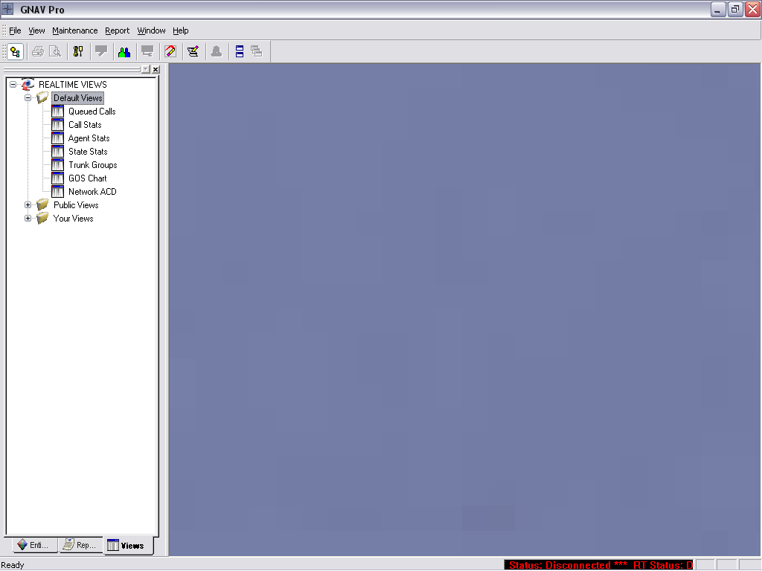

Step 7 - Select the windows that you would like to open by double clicking the desired choices. The four typical windows are:, , , and

Your window should now look similar to the following:

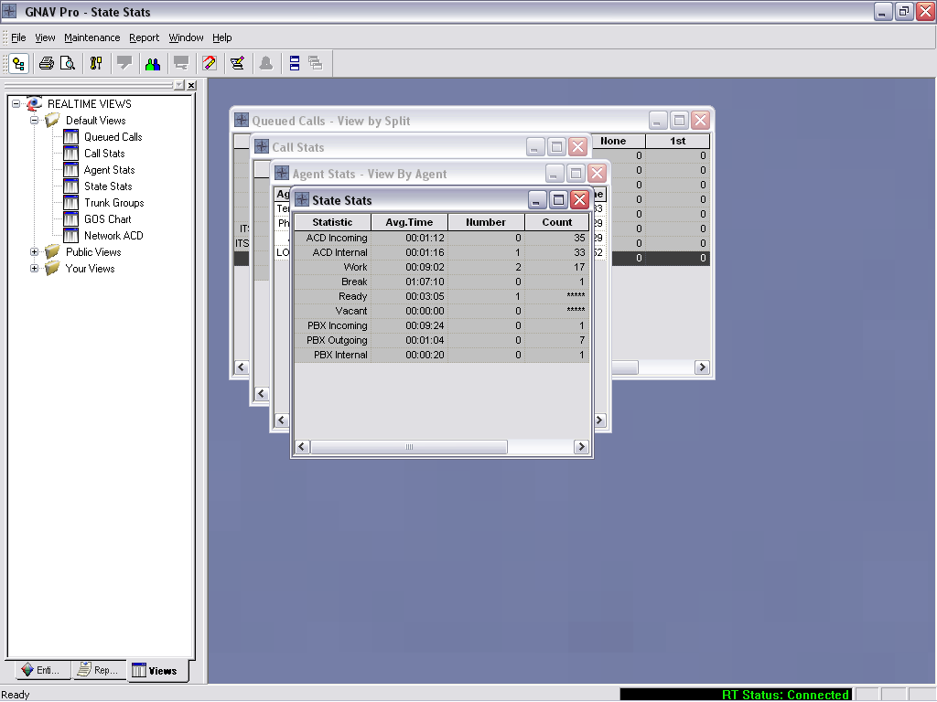

Step 8 - After all desired viewing windows have been opened; click the “tree view” icon on the taskbar to hide the tree. Clicking this icon will open or close the tree view frame at any time.

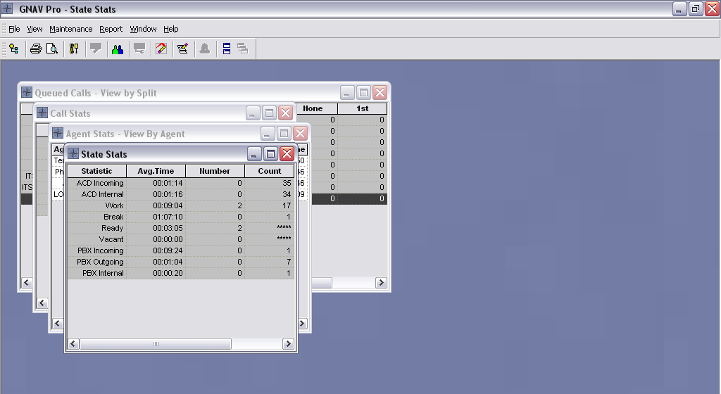

Step 9 - In the drop down menu for “Window” select “tile” and the windows will automatically fill the real time display with equal sized windows.

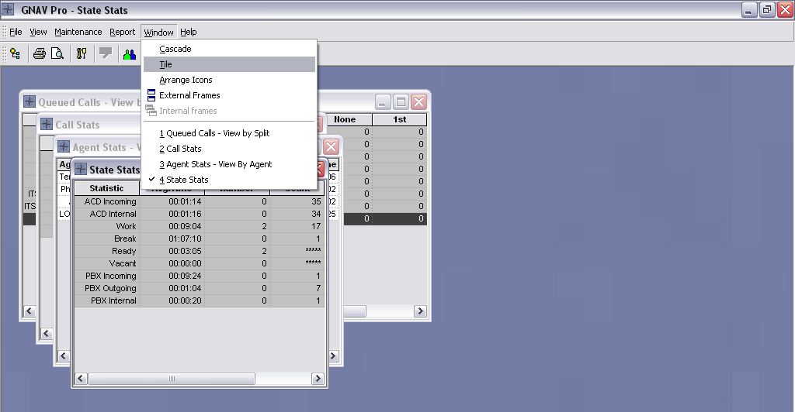

The basic layout of the real-time screen is now displayed. It should resemble the example display below:

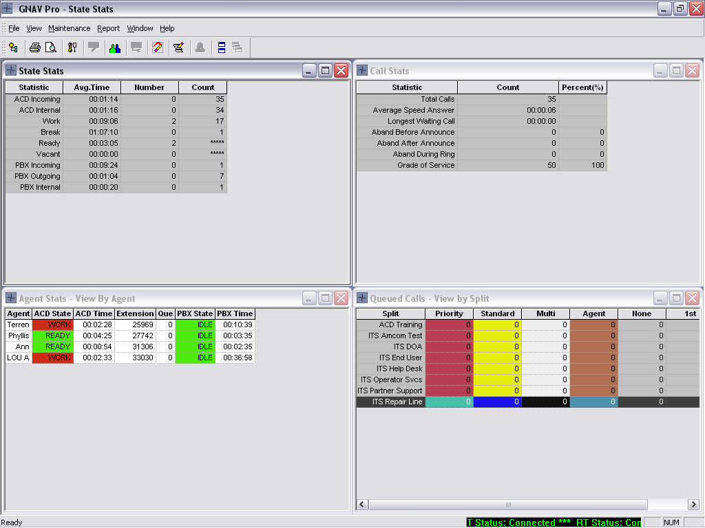

*Please Note – the viewing options are configurable and customizable. The above instructions will bring up a standard view but can be changed to meet your preferences.

Running reports:

Step 1 - Click on the “Reports” drop down menu and select “Generate Report”

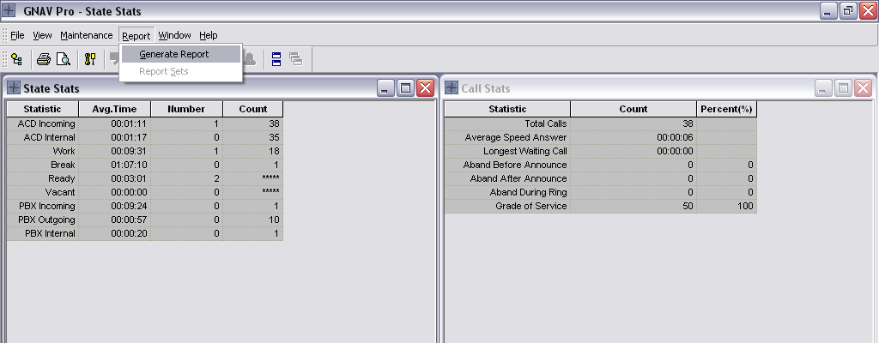

Step 2 – Select desired report and click “next”. In this example we will use Split report #1, Call Activity.

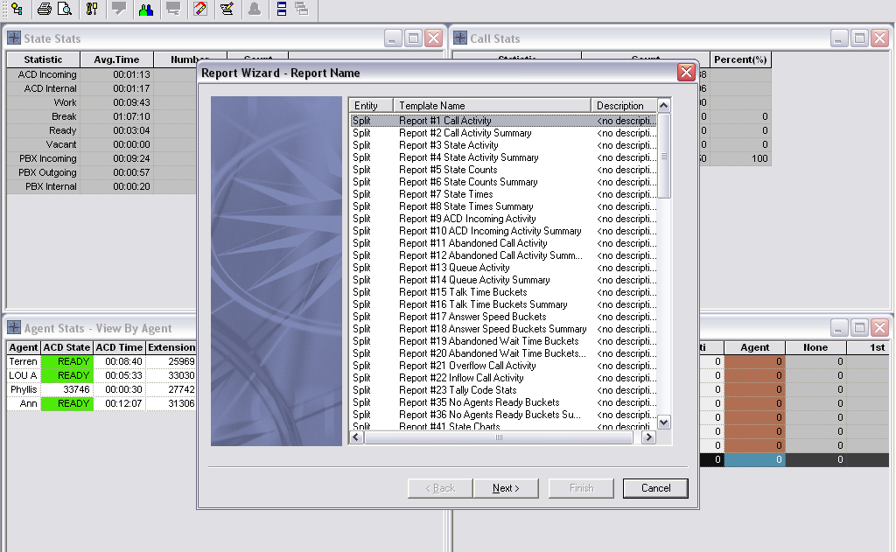
*Please Note - Reports are first grouped by entity and then by report number. This means that agent based reports like #25 (agent activity) and #39 (agent audit) will be found in order following all split based reports. Simply scroll down to select desired reports.
Step 3 – Select date (required) and time selection (optional) from the drop down menus. Click “next”.

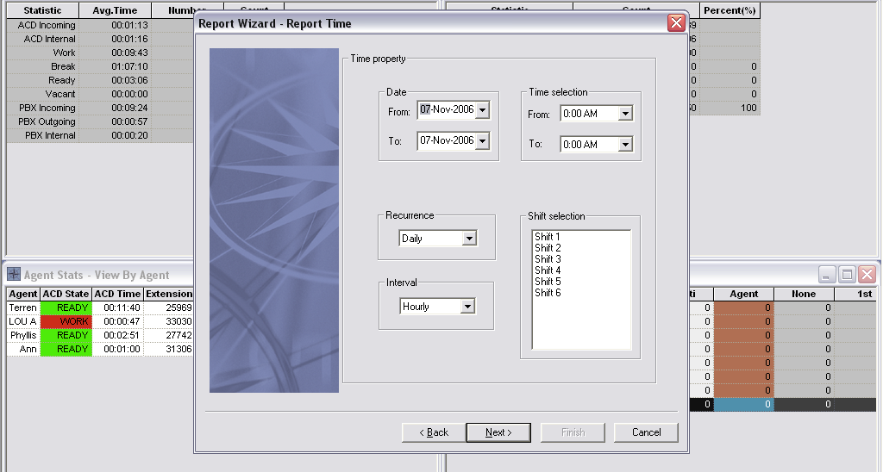

*Please Note – If “Time Selection” is changed from 0:00AM in the “From” or “To” box the report will tabulate hourly, half hour or quarterly (15 minute) intervals. If left at default, as shown above, the report will tabulate daily totals that are not broken down by hour in any way.

Step 4 - Select entity type (split in this case) and desired subjects. Click “next”.

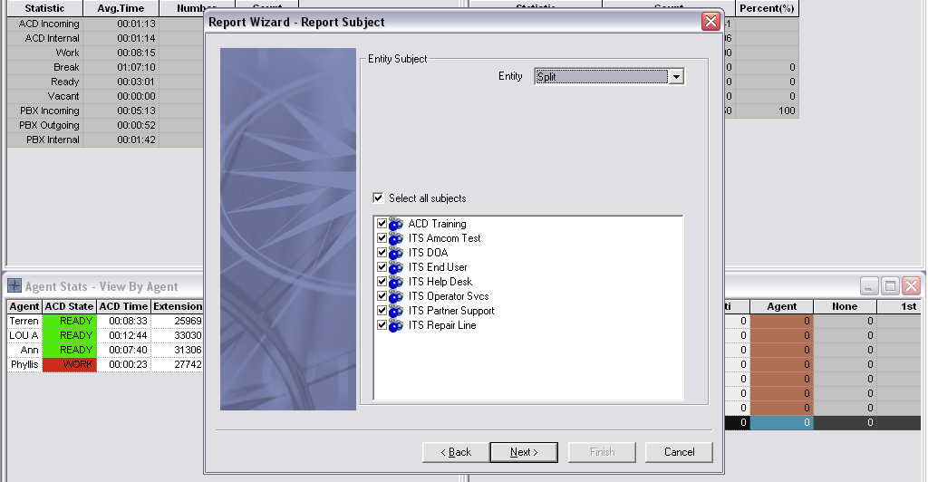
Step 5 – Select your output destination - Display, Printer, or Export. Note that the display option also gives you the ability to print or export after the report is previewed on the screen. Click “finish” and wait for report to generate

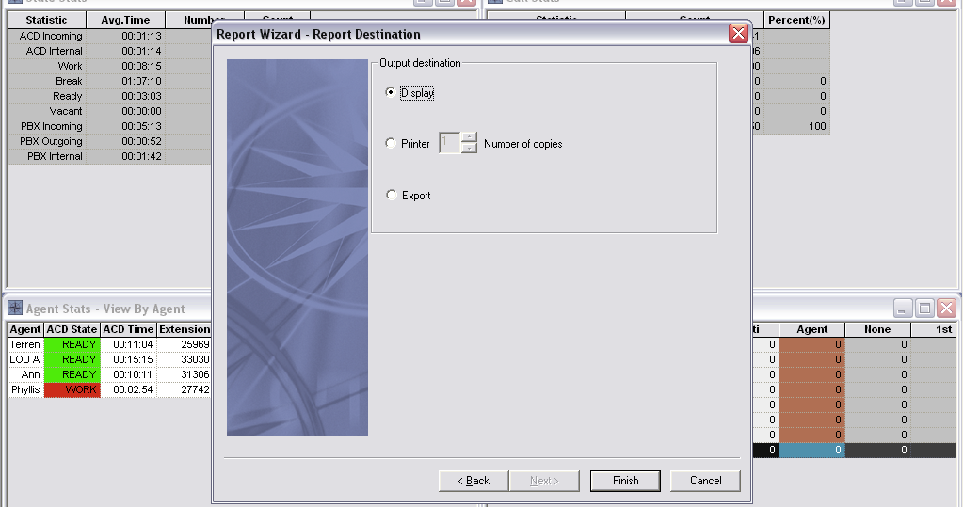

Your finished report will look something like this (below) from the display view.

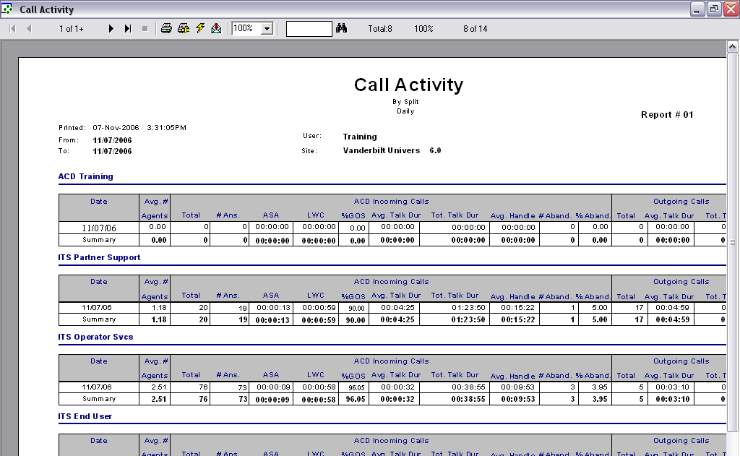
To change password:

Step 1 - Click on the blue and green “User Configuration” icon on the GNAV toolbar.

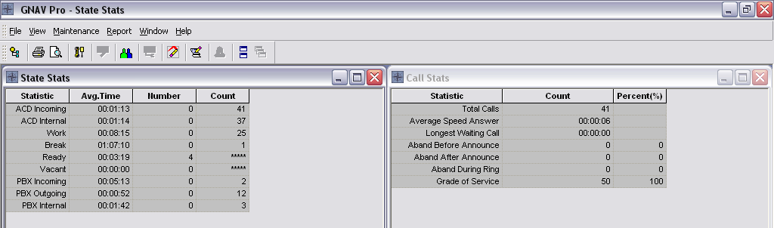

Step 2 – A “User Access” window will pop up in the center of the screen. Maximize this window by clicking on the square in the upper right hand corner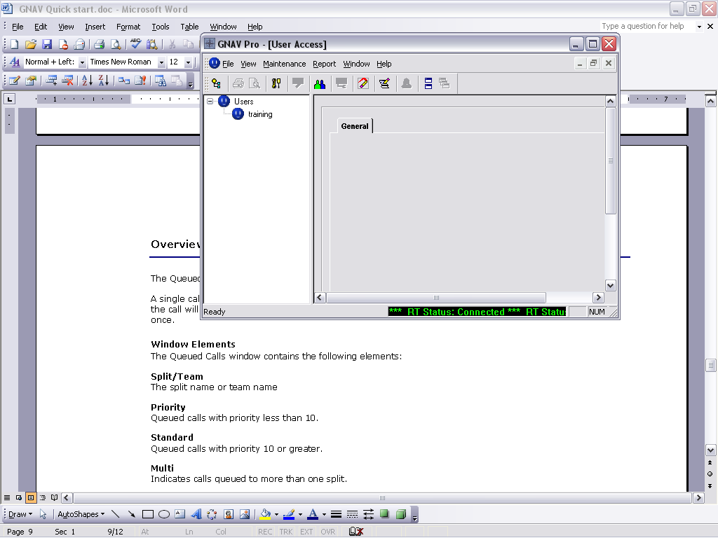, Right click on the desired user and select “Edit User”.

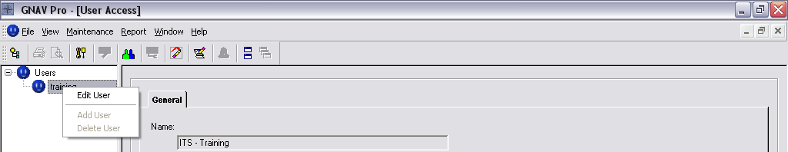

Step 3 – The orb next to the user will turn green. Click “change password”.

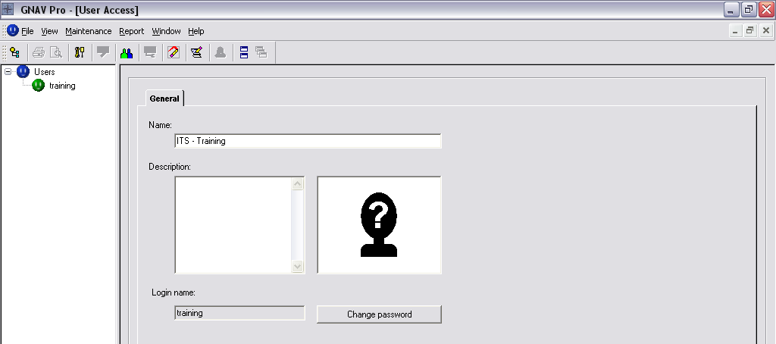

Step 4 – Type the old password, the new password and confirm the new password. Click “OK”.

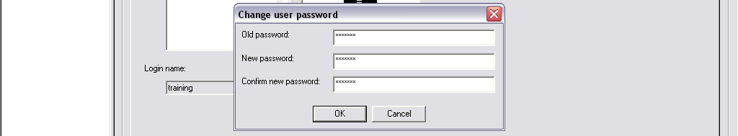

Step 5 – Click “Apply” in the lower right hand corner of the screen.

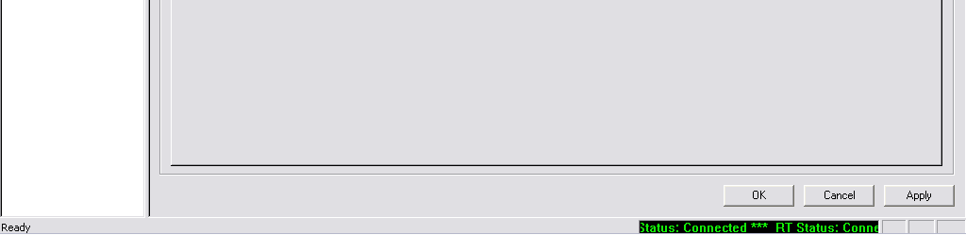

Step 6 – Right click on the user in the left frame again and select “edit user”

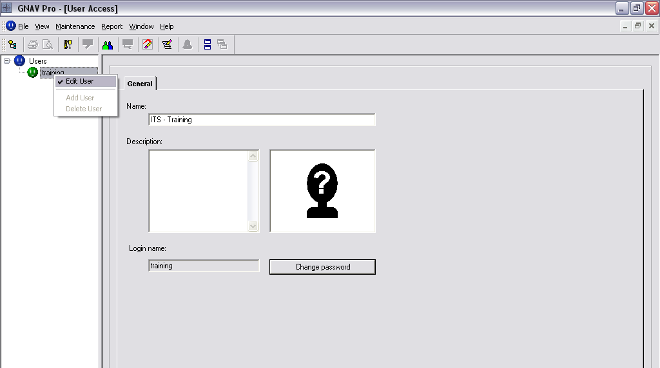

Step 6 – Make certain that the orb next to the user name has turned blue. This signifies that the editing is complete and accepted. Click “OK” to close the window.

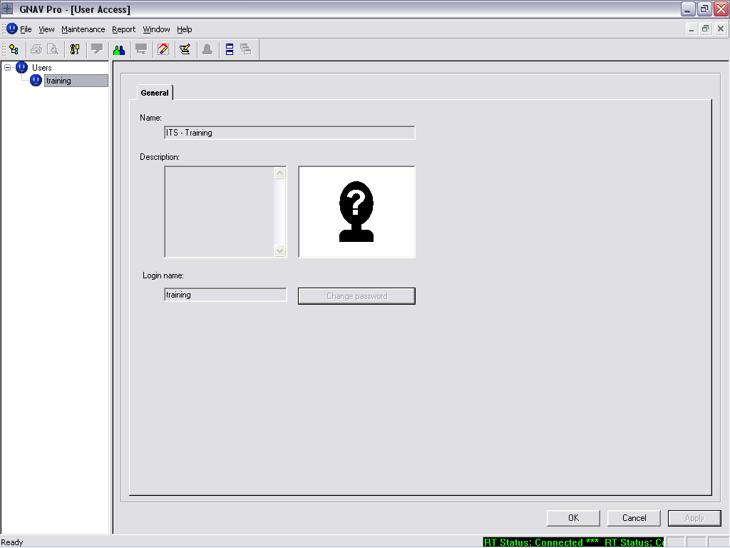
Please note - that the “Login name” may only be changed by an administrator.
The following covers an overview of each window.

Overview: The Queued Calls Window
The Queued Calls window presents the quantity of calls in split and team queues.
A single call can be queued simultaneously to a maximum of four splits. If a call is queued to multiple splits, the call will be included in the queue depth for each split; however, the "system" total will reflect the call only once.

Window Elements
The Queued Calls window contains the following elements:
Split/Team
The split name or team name
Priority
Queued calls with priority less than 10.
Standard
Queued calls with priority 10 or greater.
Multi
Indicates calls queued to more than one split.
Agent
Number of agent personal queued calls.
None
Number of calls in the queue that have not been connected to an announcement.
1st
Number of calls in the queue that are currently or have been connected to an announcement.
2nd
Number of calls in the queue that are currently or have been connected to two or more announcements.

Menu Bar Items
The menu bar contains the following item:
View By
A dropdown menu that lets you toggle between displaying queued calls by split or team.

Overview: The Call Response Statistics Window
The Call Stats window provides up-to-the-second statistics for the system, an individual split, or an individual team.

Window elements
The Call Stats window contains the following elements:
Total Calls
Number of calls presented to the subject during the current MIS day.
Average Speed Answer
Mean time between a call being presented to the subject and the call being connected to an agent during the current MIS day. The time displays in HH:MM:SS.
Longest Waiting Call
Time spent in queue by the call which currently has spent the longest period of time in queue.
Aband Before Announce
Percentage and count of calls presented to the subject but were abandoned before being connected to an announcement. The count is cumulative for the current MIS day.
Aband After Announce
Percentage and count of calls presented to the subject but were abandoned after being connected to an announcement. The count is cumulative for the current MIS day.
Aband During Ring
Percentage and count of calls presented to the subject but abandoned while ringing at an agent position. The count is cumulative for the current MIS day.
Grade of Service
Percentage and count of calls presented to the subject and answered within a customer-specified time (in seconds). The count is cumulative for the current MIS day.

Overview: The Agent Stats Window
The Agent Stats window of the Navigator displays the current status of ACD positions and the status of their companion PBX extensions.
The time that the agent has spent in the current state is shown. All agents in the subject group who are logged onto the Integrated ACD system are displayed in this window.
Another aspect of this window is its representation of an agent who is operating in multi-split mode.

Window elements
The Agent Stats window contains the following elements:
Agent
Agent identifier
ACD State
The following states can be assigned to an agent to indicate that agent's status: In, Ring, Inter, Work, Break, Ready, Vacant
ACD Time
Indicates the time that the agent has spent in the current ACD state
Extension
The agent's extension
Que
Indicates the number of calls in the agent's personal queue
PBX State
Displays the current state of the agent's ACD PBX line: IN, INTER, OUT, IDLE
PBX Time
Displays the time in the current state of the agent's PBX line

Context Menu Items
Right-click the mouse within the Agent Stats window to display the following context menu items:
Agent Audit
Displays an agent's call activity during the current MIS day
Agent Stats
Displays summary statistics of an agent's activity on an ACD position or PBX extension basis

Overview: The State Stats Window
GNAV Pro uses this window to present cumulative and momentary information related to the status of all the agents in the subject group.
The various states for an ACD Position and PBX extension are listed in the left column. The middle column displays the average time spent in the various states for all agents in the Agent Group, for the current MIS day. The far right column displays the number of agents in each of the various states at that moment.
The State Stat window displays the following data:
Statistic
The available states for an ACD position or PBX extension
Avg. Time
The average time spent in each listed state for all agents in the system (or a specific split or split group) for the entire MIS day, updated in real time.
Number
The number of agents currently in each of the listed states.
Count
The number of times an agent entered each listed state. The count is for all agents in the system (or a specific split or split group) for the entire MIS day, updated in real time.

