OAC ISSUE: Incorrect Data Timezone Displayed On BI Publisher Reports (Doc ID 2709802.1)
Dates may show as a few hours to minus one day.
SYMPTOMS | Incorrect dates/times on reports.  The timezone for your BI Publisher report data is incorrect  All account settings are set to GMT-6  Report data shows incorrectly as 6 hours earlier than the times in the xml data.  The times from the xml data are correct.  The Date Formatting selection changes the actual date in the report.  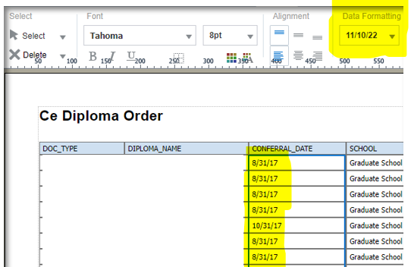
SOLUTION | 1. Login to BI Publisher Enterprise.  2. From the Catalog listing select to Edit the report.  3. Select Edit for the layout.  4. After the Layout Editor opens select the label for the date data that has the problem.  In the Properties on the lower left, scroll down and set Ignore User Timezone to TRUE.  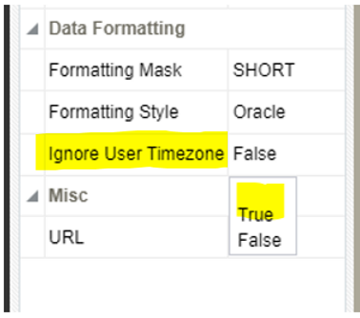  Save the changes and test.

